SCS2211

Laboratory II

21000298

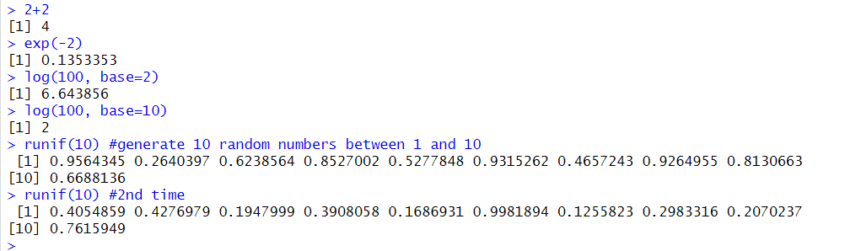1)

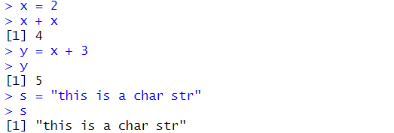2)

3)

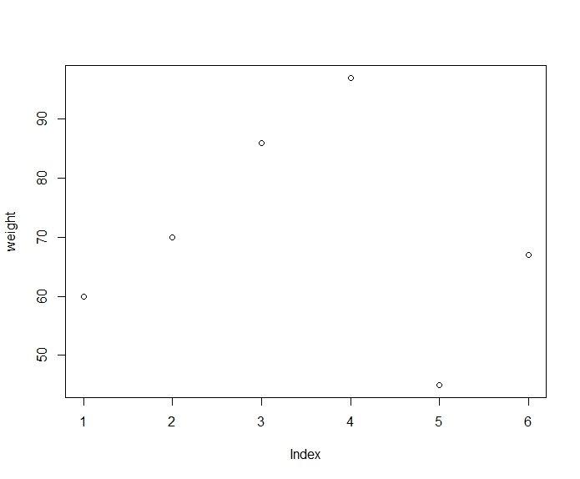

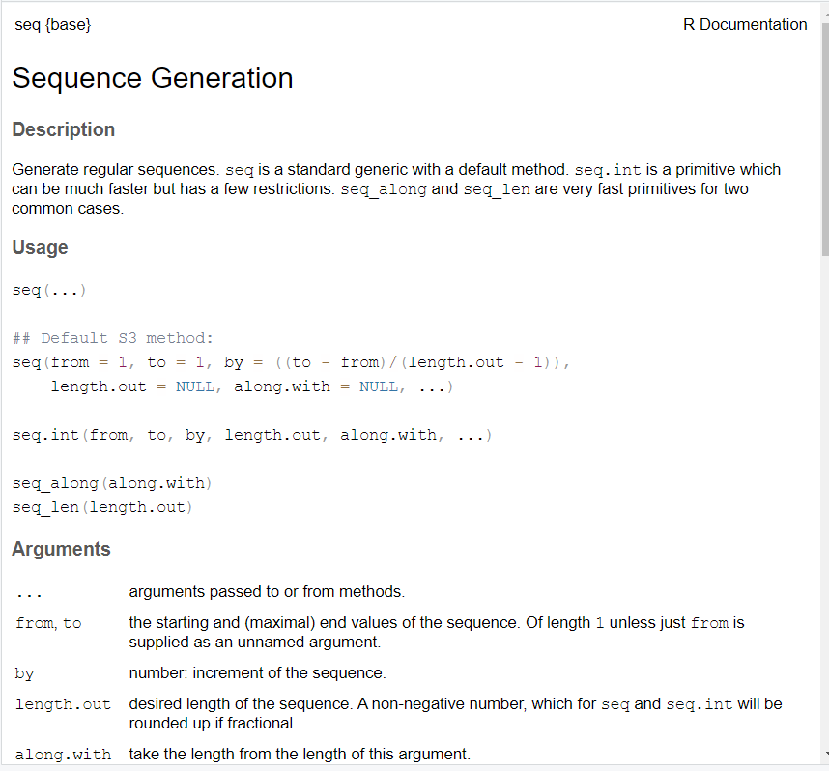

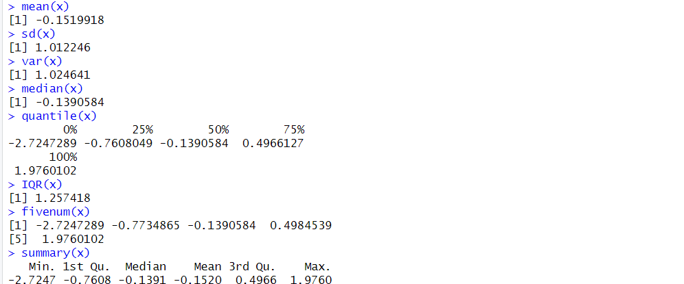4)

5)

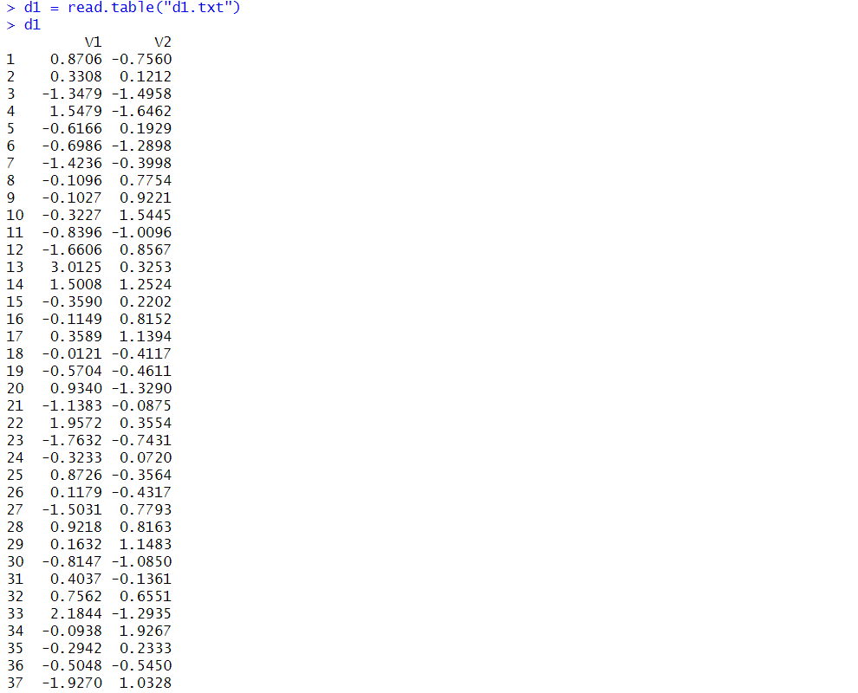

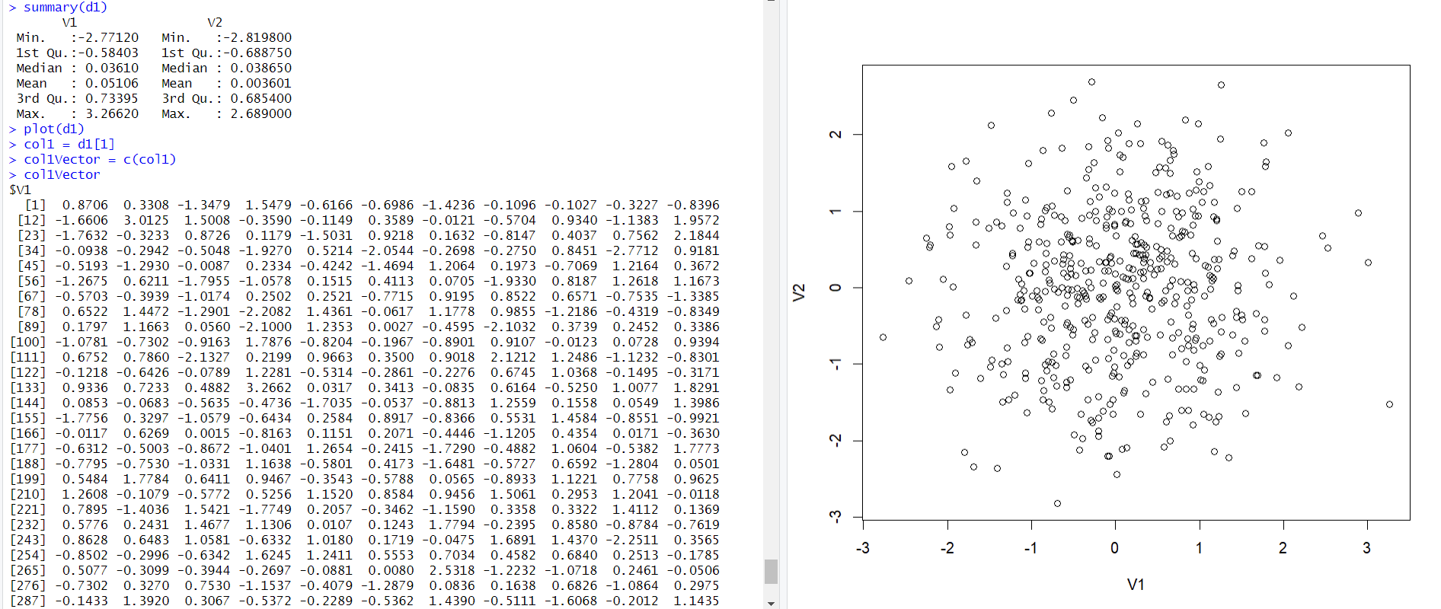

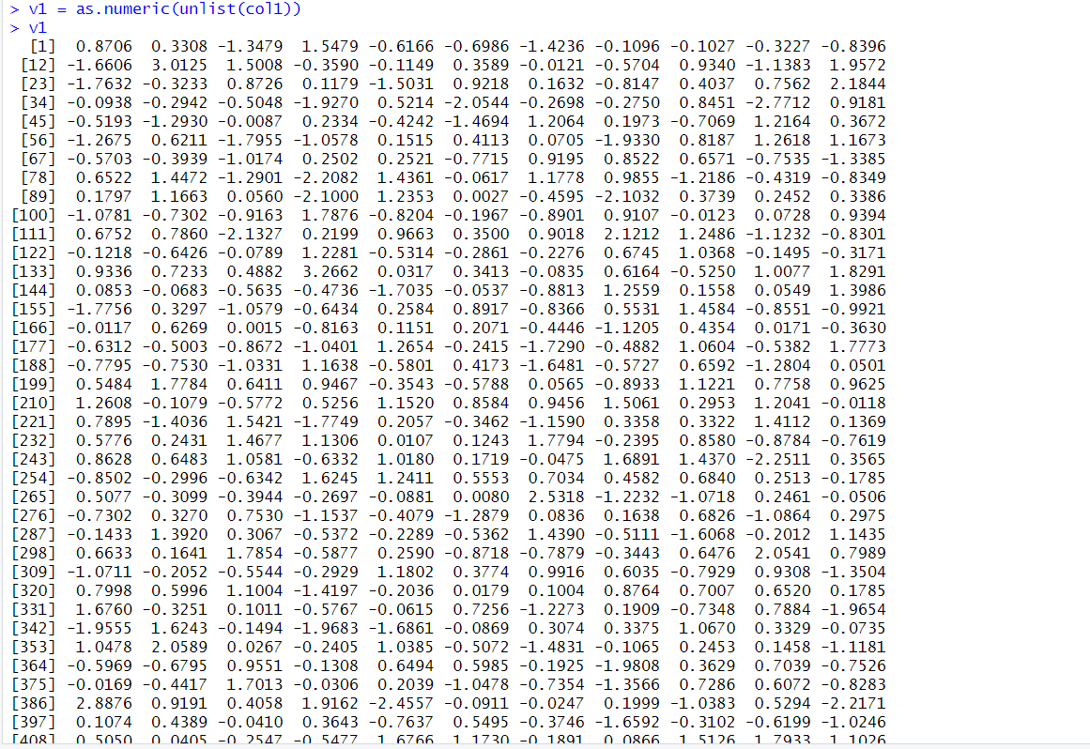

6)

7)

8)

10)

11)